**Women Tech Maker Madurai 2018**

**Date: 07.04.2018**

**Venue: Armed Reserve DSP Office, Madurai.**

     After the finish of Artificial Intelligence Family Challenge program in the morning session the never get worn out and furthermore composed an another superb occasion in that same day for ladies understudies to propel them in advanced innovation. Our Women TechMakers Madurai and GeeksUp have composed the occasion to engage ladies' learning in Technology Armed Reserve DSP Office, Madurai. The occasion saw in excess of 50+ Energetic Girls and 10+ Police Officers. Mr.Senthil Kumar, Ex Employee of Qualcomm and Samsung, Hosted and took away the show vivaciously, every one of the speakers motivated Girls with their discourse. All were interfaced with the speakers for the whole program.

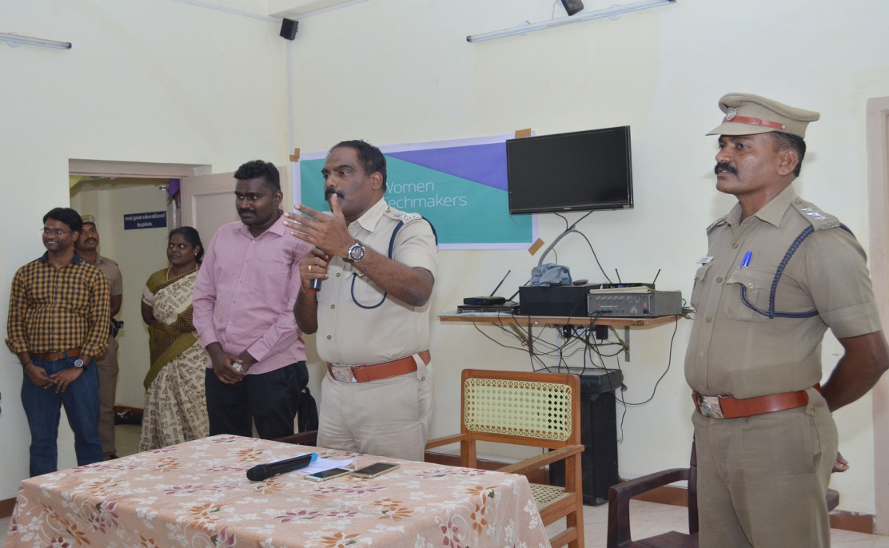

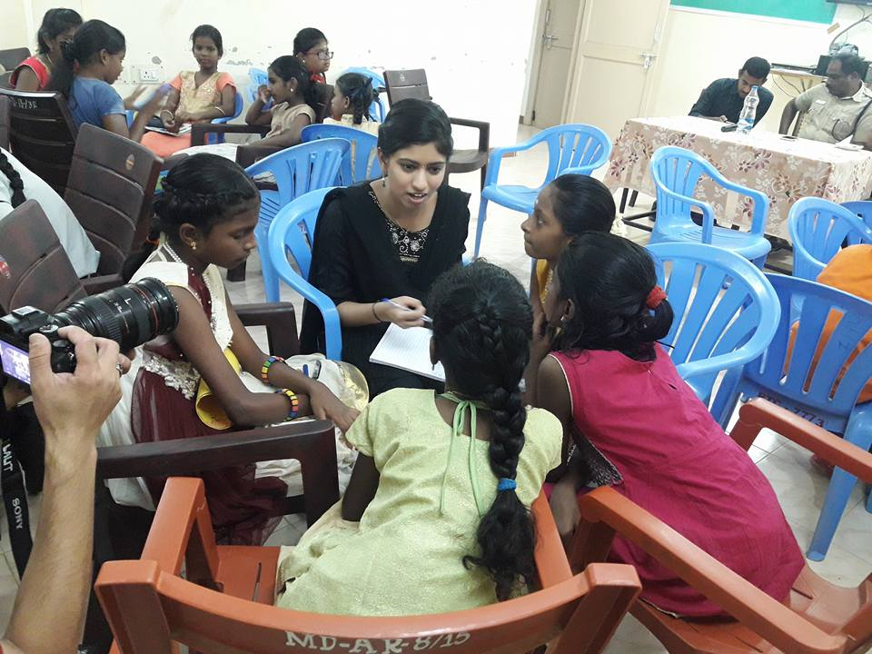

Welcome note was given by Mr.Murugan Deputy Superintendent of Police, Madurai District. Visitor speech to rouse young ladies in innovation given by Mr. Manivannan, Superintendent of police, Madurai. Enabling ladies to seek after their fantasies and construct their own versatile application to determine the issues progressively. Having a decent variety of points of view and thoughts prompts better basic leadership, more important items, and makes the business considerably more fascinating. We trust that by making the correct conditions, projects and arrangements, ladies in tech are better situated to drive change in the business and past. Technovation challenge 2018 young ladies were pitch their thought and got a great input from group of onlookers. Thought isn't great when its ideating, it would be incredible when it should executing, Two times technovation victor Ms.Girija and Ms.Vaishnavi shared their involvement in Women TechMakers and Technovation to technovation Girls like how to pitch and make paper model. Young ladies began their following stage (paper prototype) of technovation. Such a magnificent occasion gone at Madurai that is Women Tech Maker @ 2018.